
Yes

Document No: 19Jul2025 A

Hardening and UAT Document

JGPC Server and Client Security hardening and UAT

Document Control
Action | Name | Date
Author
Author
Author
Version
Version | Date | Change | Affected Pages | Remark
1.0
2.0 |  | Updated
3.0 |  | Reviewed and Comments

Distribution List
Name | Organization | Title

Only Distributed to Distribution List.

Contents

Introduction 3
Hardening Tools and Processes 3
General Hardening Check List 4
Server Services Hardening Check List 15
AD Server Security Policy Hardening Check List 18
Internet Explorer Hardening Check List 22
Windows Server User Right Assignment Hardening Check List 26
Windows Host Based Firewall Hardening Check List 27
Account Policies Hardening Check List for GIC. 29
AppLocker Hardening Check List for GIC. 31
Server Performance Optimization 32
Windows Patch Update 37
Antivirus Setting 38

Introduction
This document represents the recommendations of Hilal Computers for a hardening of Active Directory Servers, Member Servers and Domain Client for GIC. These recommendations are based upon Microsoft formidable experience and understanding of Enterprise Computing. Substantial time and effort was spent collecting requirements and feedback from the GIC IT to ensure that all the stakeholder’s needs were represented and taken in to consideration.

Hardening Tools and Processes
Tool/ Processes | URL | Description
Best Practice Analyzer (BPA) | https://docs.microsoft.com/en-us/windows-server/administration/server-manager/run-best-practices-analyzer-scans-and-manage-scan-results | We use BPA Tool to determine the server roles configured as per best practices
Security Baseline analyzer | https://www.microsoft.com/en-sa/download/details.aspx?id=19892 | The Microsoft Baseline Security Analyzer provides a streamlined method to identify missing security updates and common security misconfigurations.
Policy Analyzer | https://www.microsoft.com/en-us/download/details.aspx?id=55319 | This set of tools allows enterprise security administrators to download, analyze, test, edit and store Microsoft-recommended security configuration baselines for Windows
Group Policy Object (GPO) |  | We Use Local Group Policy to harden the server
Directory Services Diagnostic Utilities |  | DCDiag,
Local Admin Password Manager (LAMP)
PowerShell Script |  | We use PowerShell script to disable 8.3 Filename and
SecPol Tool |  | We Use Local Policy Manager to harden the server
Windows Services |  | We use Window Services to Harden the unnecessary services

General Hardening Check List

Below is the general Hardening guideline for all Domain Controller in GIC Environment.
Parameter | Action | Yes / No
Keep all servers at the same revision level | 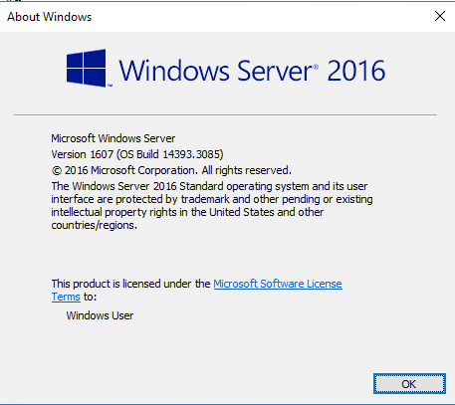 | Yes
Disable automatic administrative logon to the recovery console. | 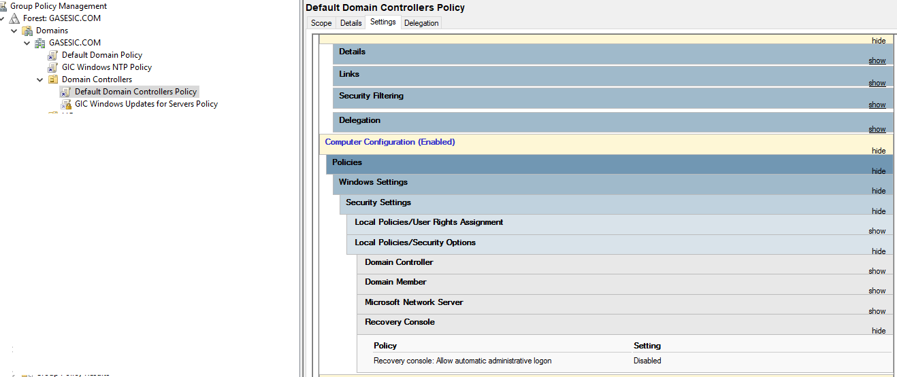 | Yes
Configure the device boot order to prevent unauthorized booting from alternate media. |  | Yes
Disable IP Version 6 | 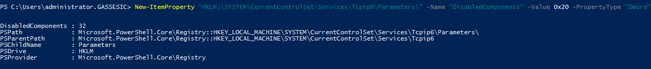 | Yes
Ensure your administrative and system passwords meet password best practices. |  | Yes
Disable the guest account. | 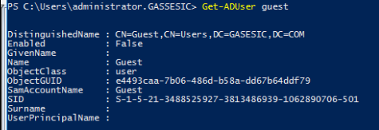 | Yes
Do not allow “everyone” permissions to apply to anonymous users. | 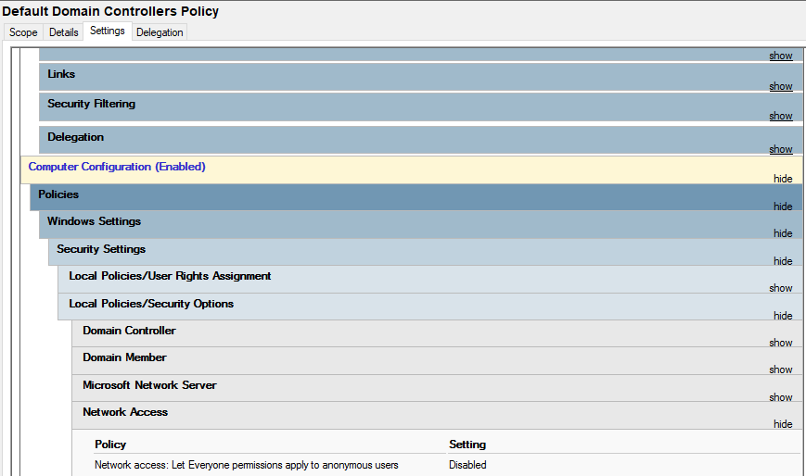
Enable the Windows firewall in all profiles (domain, private, public) and configure it to block inbound traffic by default. | 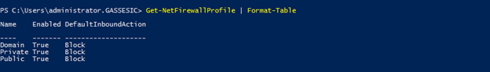
Disable anonymous SID/Name translation. | 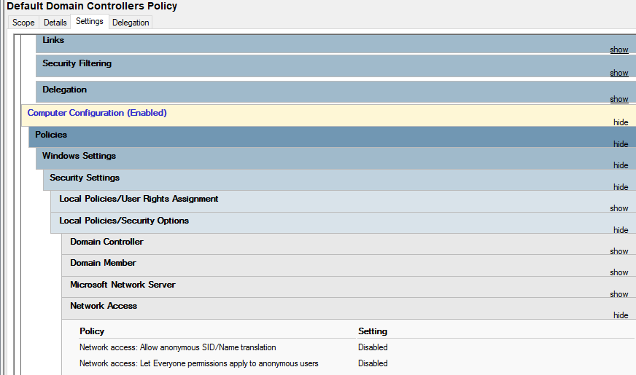 | Yes
Do not grant any users the 'act as part of the operating system' right. | 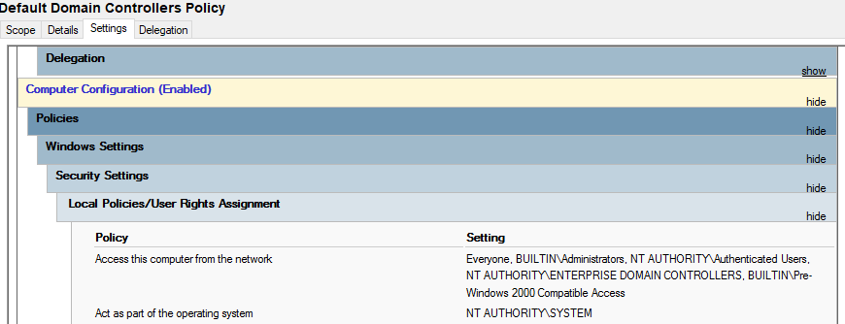 | Yes
Deny guest accounts the ability to log on as a service, a batch job, locally or via RDP. | 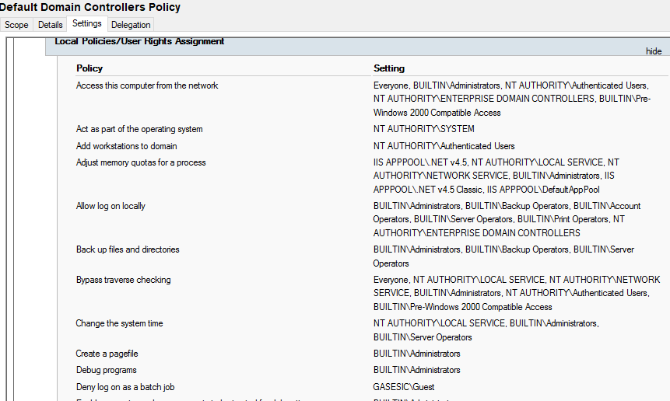
Remove Enable LMhosts lookup. | 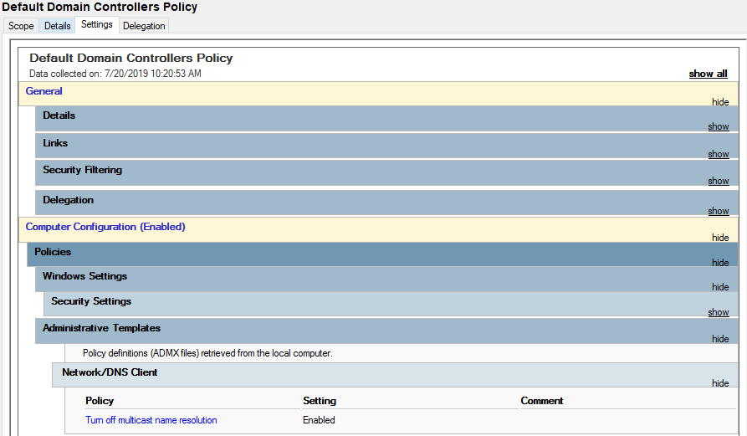
Disable unneeded services | 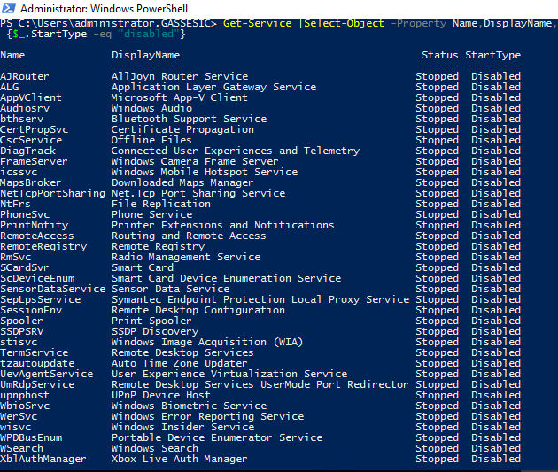 | Yes
Display a legal notice before the user logs in: | 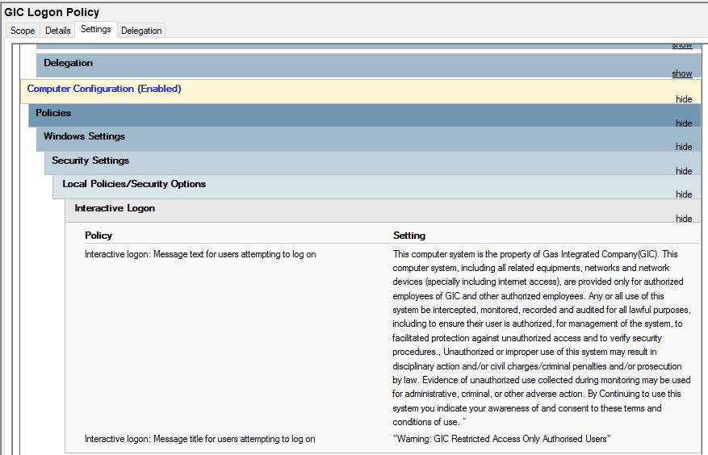 | Yes
Do not use AUTORUN | 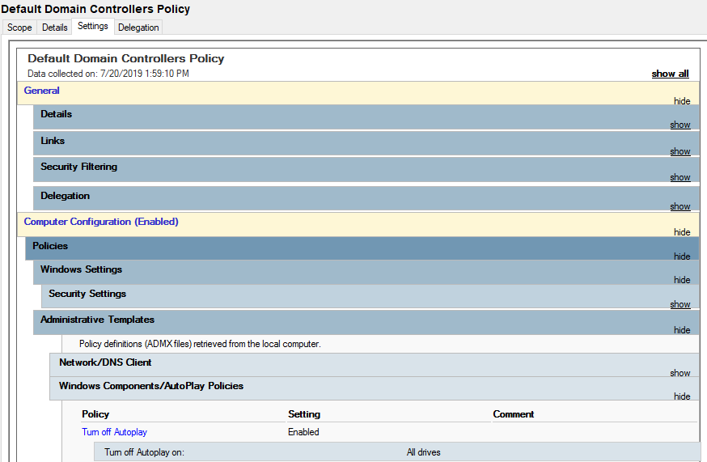 | Yes
Configure a machine inactivity limit to protect idle interactive sessions. |  | Yes
Accidental Deletion Protection Enabled ON OUs |  | Yes
Ensure all volumes are using the NTFS file system. | 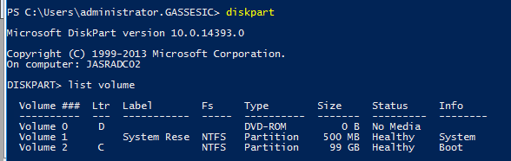
Monitor and log all privileged activity. |  | Yes
Secure Built-in Administrator Accounts by checking flag Account is sensitive and cannot be delegated | 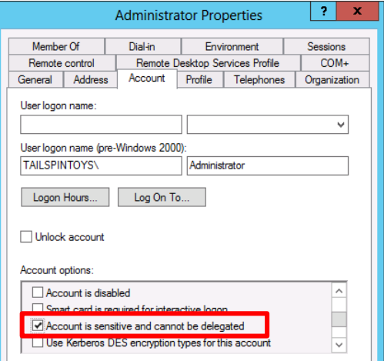
Configure the Event Log retention method to overwrite as needed and size up to 4GB. |  | Yes
Domain Functional level ‘Windows 2012 R2” | 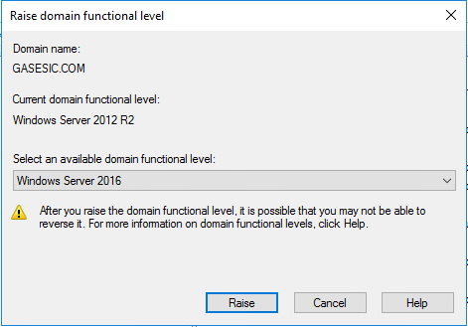 | Yes
All Admin Should be Protected Users” Security Group” | 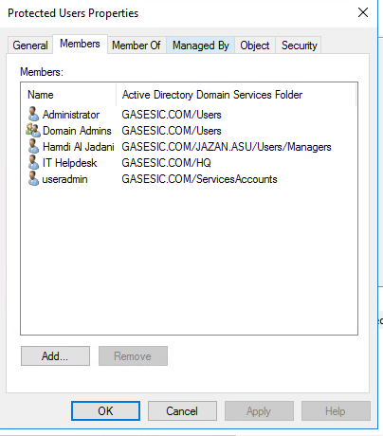 | Yes
Rename Domain Administrator Account |  | Yes
Least Privilege Group and Users | 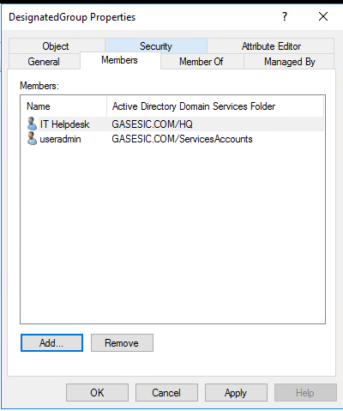 | Yes
All domain authentication should be set to: “Send NTLMv2 response only\refuse LM & NTLM.” |  | Yes
Disable Net Bios over TCP/IP | Disable NetBIOS over TCP/IP | Yes
Enable Name Service Logging | 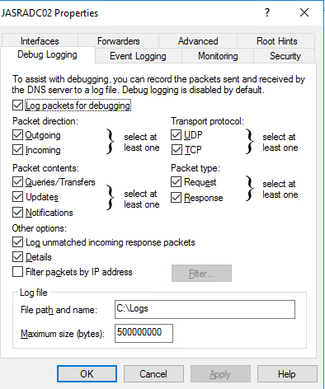 | Yes
DNS to Only Support Secure Dynamic Update | 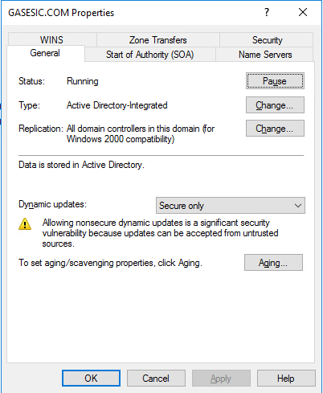 | Yes
Enable Event Viewer Logging | 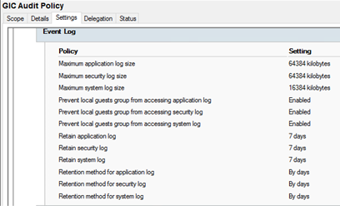 | Yes
DNS Secure Cache against pollution should be enabled | 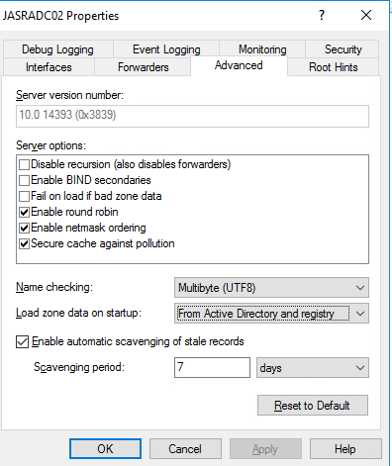 | Yes
All Site should be bind with Subnet ID |  | Yes
Enable Name Protection on DHCP | 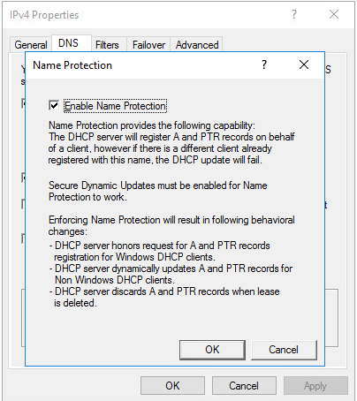 | Yes
SysVol & NTDS to be Excluded by Anti-Virus |  | Yes
Enable Active Directory Recycle Bin | 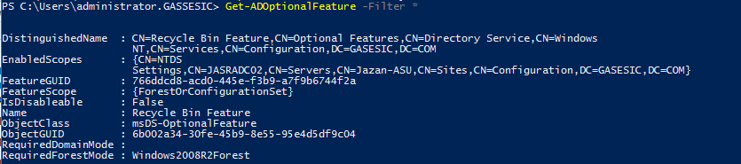 | Yes
Set 8.3 Naming Creation on a per Volume basis | 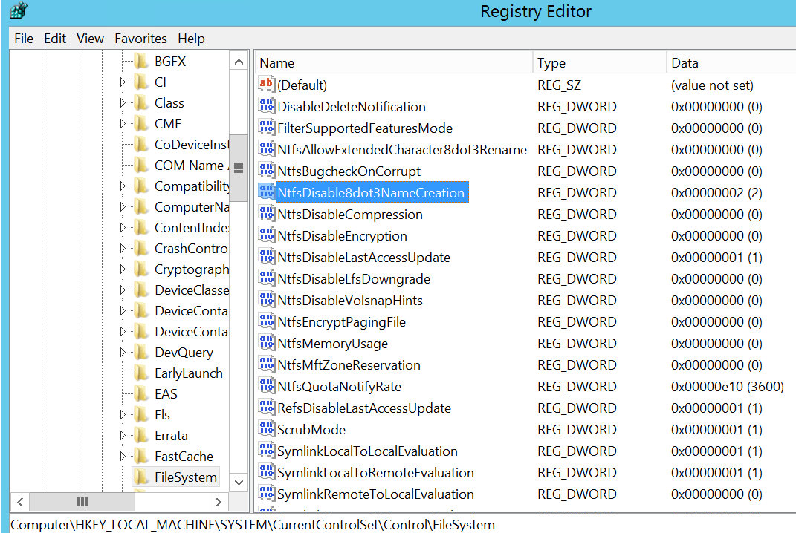 | Yes
Enable LSA Protection |  | Yes
Disable SMB v1 | 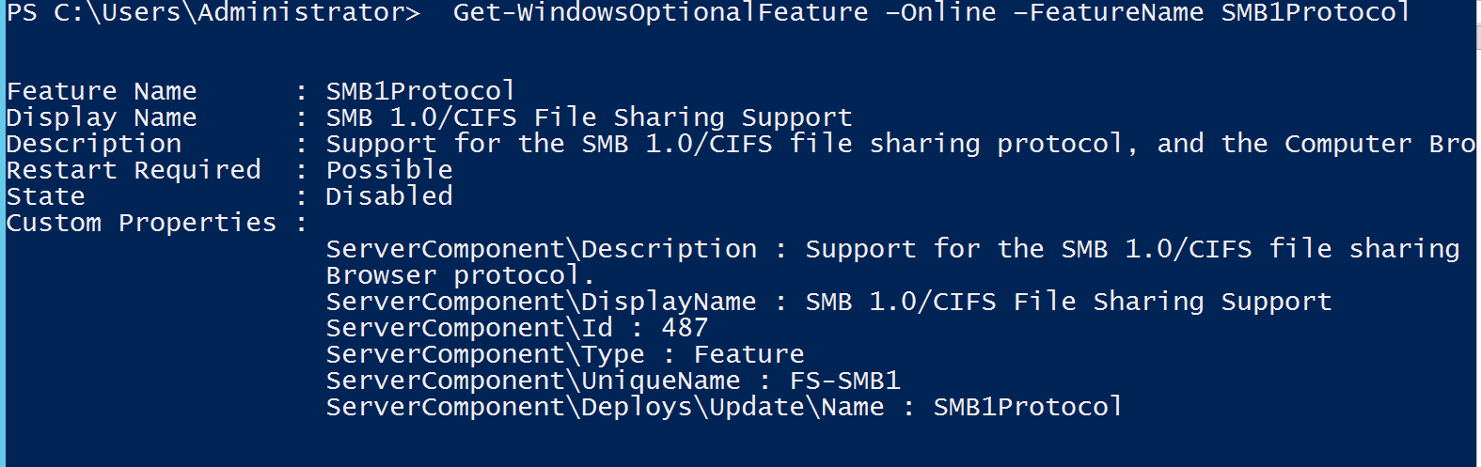  Enable SMBv2/3  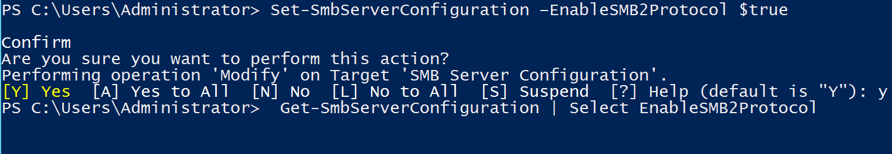 | Yes
Disable RDP | RDP Will be disabled | Yes
Disable Telnet Services |  | Yes
Apply UAC restrictions to local accounts on network logon | 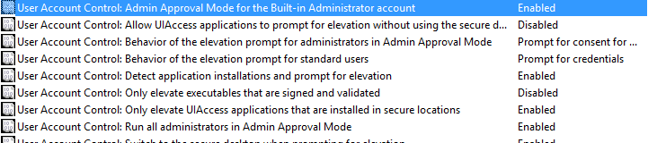 | Yes
DNS Zone | AD Integrated Zone , Replication set to All domain controler | Yes
DNS Scavenging | 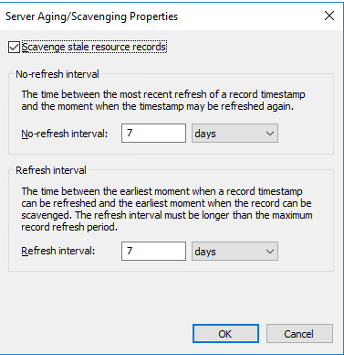 | Yes
Install Anti-Virus |  | Yes

Server Services Hardening Check List
Below is the Hardening guideline for all Domain Controller Server in GIC Environment.
Services | Status |  | Yes / No
Printer Spooler Service | Disabled | if you do not have a printer attached to your computer and you do not use software with virtual printers such as Microsoft XPS Document Writer or Snagit for instance, you can disable it | Yes
Telnet Services | Disabled |  | Yes
Remote Registry | Disabled | this service enables remote users to modify the Windows Registry. Some say that having this service turned on can pose security issues, and therefore, choose to disable it. | Yes
Net.Tcp Port Sharing | Disabled | Provides ability to share TCP ports over the net.tcp protocol. | Yes
Software Protection | Disabled |  | Yes
Routing and Remote Access | Disabled | This service offers routing services to businesses in local area and wide area networks. It allows computers to dial into the local computer for it to get access to the local network | Yes
Remote Desktop Services | Disabled | Remote Desktop Protocol is a protocol developed by Microsoft which provides Windows users with a graphical interface to another computer. it is safe to disable this service | Yes
Portable Device Enumerator Service | Disabled | Enforces group policy for removable mass-storage devices. Enables applications such as Windows Media Player and Image Import Wizard to transfer and synchronize content using removable mass-storage devices. | Yes
Printer Extensions and Notifications | Disabled | This service opens custom printer dialog boxes and handles notifications from a remote print server or a printer. | Yes
Remote Desktop Services User Mode Port Redirector: | Disabled | Allows the redirection of Printers/Drives/Ports for RDP connections | Yes
Fax | Disabled |  | Yes
Radio Management Service | Disabled | Radio Management and Airplane Mode Service | Yes
Internet Connection Sharing (ICS) | Disabled | Provides network address translation, addressing, name resolution and/or intrusion prevention services for a home or small office network. | Yes
Sensor Data Service | Disabled | Delivers data from a variety of sensors | Yes
 | Disabled |  | Yes
Internet Explorer ETW Collector Service | Disabled |  | Yes
Telephony | Disabled |  | Yes
Windows Audio | Disabled |  | Yes
AllJoyn Router Service | Disabled | enables Windows to communicate with nearby internet of Things devices. Unless you have such devices, you do not need this service to run | Yes
Application Layer Gateway Service | Disabled | offers support for 3rd party protocol plug-ins for Internet Connection Sharing. Modern computers do not need or use such features so this service can be safely disabled | Yes
Windows Image Acquisition (WIA) | Disabled | Provides image acquisition services for scanners and cameras | Yes
Bluetooth Audio Gateway Service | Disabled | allows you to configure Cortana while using Bluetooth. If you do not have Bluetooth on your device or if you do not intend to talk to Cortana using a Bluetooth headset, you can disable it | Yes
Bluetooth Support Service: | Disabled | unless you use Bluetooth devices such as keyboards, mice, printers or phones, you can disable this service. Keep in mind that, if you choose to disable this service, then Bluetooth devices are no longer detected and recognized. Also, the already connected Bluetooth devices may fail to work correctly | Yes
Certificate Propagation | Disabled | if you do not use Smart Cards, which are sometimes used in large organizations, it is safe to disable this service | Yes
Downloaded Maps Manager | Disabled |  | Yes
Offline Files: | Disabled | unless you use the Offline Files feature from Windows, you can disable it. Note that this service is not available in the Home versions of Windows. | Yes
Phone Service: | Disabled | manages the telephony state on your Windows device and might be used by some VoIP apps. If you do not use such apps, it is safe to disable it | Yes
Windows Biometric | Disabled |  | Yes
Windows Camera Frame Service | Disabled |  | Yes
Windows Insider Service: | Disabled | Lets you use your Windows server PC while enrolled in the Windows Insider Program. Unless you want to beta test Windows server , you can safely disable this service | Yes
Xbox Live Auth Manager | Disabled |  | Yes
Xbox Live Game Save | Disabled |  | Yes
Smart Card: | Disabled | Smart Cards are used for safety reasons in large organizations or corporations. The typical home user does not need this service to be running. | Yes
Smart Card Device Enumeration Services | Disabled | Same as a above | Yes
Smart Card Removal Policy | Disabled | Same as a above | Yes
Windows Error Reporting Service | Disabled | this service is used to report system errors to Microsoft. | Yes
Connected User Experiences and Telemetry | Disabled | The Connected User Experiences and Telemetry service enables features that support in-application and connected user experiences. | Yes



AD Server Security Policy Hardening Check List
Below is the Active Directory Security Policy Hardening guideline for all Domain Controller Server in GIC Environment.
Policy Object | Applicable. | Yes/ No
Accounts: Guest account status | Disabled | Yes
Accounts: Limit local account use of blank passwords to console logon only | Enabled | Yes
Audit: Force audit policy subcategory settings (Windows Vista or later) to override audit policy category settings | Enabled | Yes
Interactive logon: Machine account lockout threshold | 5 | Yes
Interactive logon: Machine inactivity limit | 900 seconds | Yes
Interactive logon: Smart card removal behavior | Lock Workstation | Yes
Interactive logon: Message text for users attempting to log on | This computer system is the property of Gas Integrated Company(GIC). This computer system including all related equipment’s networks and network devices (specially including internet access) are provided only for authorized employees of GIC and other authorized employees. Any or all use of this system be intercepted monitored recorded and audited for all lawful purposes including to ensure their user is authorized for management of the system to facilitated protection against unauthorized access and to verify security procedures. Unauthorized or improper use of this system may result in disciplinary action and/or civil charges/criminal penalties and/or prosecution by law. Evidence of unauthorized use collected during monitoring may be used for administrative criminal or other adverse action. By Continuing to use this system you indicate your awareness of and consent to these terms and conditions of use. | Yes
Interactive logon: Message title for users attempting to log on | Warning: This System Restricted to Authorized User | Yes
Microsoft network client: Digitally sign communications (always) | Enabled | Yes
Microsoft network client: Digitally sign communications (if server agrees) | Enabled | Yes
Microsoft network client: Send unencrypted password to third-party SMB servers | Disabled | Yes
Microsoft network server: Amount of idle time required before suspending session | 15 | Yes
Microsoft network server: Digitally sign communications (always) | Enabled | Yes
Microsoft network server: Digitally sign communications (if client agrees) | Enabled | Yes
Network access: Allow anonymous SID/Name translation | Disabled | Yes
Network access: Do not allow anonymous enumeration of SAM accounts | Enabled | Yes
Network access: Do not allow anonymous enumeration of SAM accounts and shares | Enabled | Yes
Network access: Let Everyone permissions apply to anonymous users | Disabled | Yes
Network access: Restrict anonymous access to Named Pipes and Shares | Enabled | Yes
Network security: Allow Local System to use computer identity for NTLM | Enabled | Yes
Network security: Allow LocalSystem NULL session fallback | Disabled | Yes
Network security: Do not store LAN Manager hash value on next password change | Enabled | Yes
Network security: Force logoff when logon hours expire | Enabled
Network security: LAN Manager authentication level | Send NTLMv2 Responses only, Refuse LM and NTLM | Yes
Network security: LDAP client signing requirements | Negotiate Signing | Yes
Network security: Minimum session security for NTLM SSP based (including secure RPC) clients | Require NTLMv2 session security, Require 128bit encryption | Yes
Network security: Minimum session security for NTLM SSP based (including secure RPC) servers | Require NTLMv2 session security, Require 128bit encryption | Yes
System objects: Require case insensitivity for non-Windows subsystems | Enabled | Yes
System objects: Strengthen default permissions of internal system objects (e.g., Symbolic Links) | Enabled | Yes
User Account Control: Admin Approval Mode for the Built-in Administrator account | Enabled | Yes
User Account Control: Allow UIAccess applications to prompt for elevation without using the secure desktop. | Disabled | Yes
User Account Control: Behavior of the elevation prompt for administrators in Admin Approval Mode | Prompt for consent on the secure desktop | Yes
User Account Control: Behavior of the elevation prompt for standard users | Automatically deny elevation requests | Yes
User Account Control: Detect application installations and prompt for elevation | Enabled | Yes
User Account Control: Only elevate UIAccess applications that are installed in secure locations | Enabled
User Account Control: Run all administrators in Admin Approval Mode | Enabled | Yes
User Account Control: Virtualize file and registry write failures to per-user locations | Enabled | Yes
Access Credential Manager as a trusted caller | No One (blank) | Yes
Access this computer from the network | Authenticated Users, Administrators | Yes
Act as part of the operating system | No One (blank) | Yes
Allow log on locally | Administrators | Yes
Backup files and directories | Administrators | Yes
Create a pagefile | Administrators | Yes
Create a token object | No One (blank) | Yes
Create global objects | Administrators, LOCAL SERVICE, NETWORK SERVICE, SERVICE | Yes
Create permanent shared objects | No One (blank) | Yes
Create Symbolic Links | Administrators
Debug programs | Administrators | Yes
Deny access to this computer from the network | Guests | Yes
Deny log on locally | Guests | Yes
Deny log on through Remote Desktop Services | Guests | Yes
Enable computer and user accounts to be trusted for delegation | No One (blank) | Yes
Force shutdown from a remote system | Administrators | Yes
Generate security audits | Local Service, Network Service | Yes
Impersonate a client after authentication | Administrators, SERVICE, Local Service, Network Service | Yes
Increase scheduling priority | Administrators | Yes
Load and unload device drivers | Administrators | Yes
Lock pages in memory | No One (blank) | Yes
Manage auditing and security log | Administrators | Yes
Modify firmware environment values | Administrators | Yes
Perform volume maintenance tasks | Administrators | Yes
Profile single process | Administrators | Yes
Restore files and directories | Administrators | Yes
Take ownership of files or other objects | Administrators | Yes

Internet Explorer Hardening Check List
Below is the Hardening guideline for all Domain Controller Services in GIC Environment.
Policy Name | Status | Yes / No
Don't run antimalware programs against ActiveX controls | Enabled: Disable | Yes
Initialize and script ActiveX controls not marked as safe | Enabled: Disable | Yes
Access data sources across domains | Enabled: High Safety | Yes
Allow active scripting | Enabled: Disable | Yes
Allow binary and script behaviors | Enabled: Disable | Yes
Allow cut copy or paste operations from the clipboard via script | Enabled: Disable | Yes
Allow drag and drop or copy and paste files | Enabled: Disable | Yes
Allow file downloads | Enabled: Disable | Yes
Allow font downloads | Enabled: Disable | Yes
Allow loading of XAML files | Enabled: Disable | Yes
Allow META REFRESH | Enabled: Disable | Yes
Allow only approved domains to use ActiveX controls without prompt | Enabled: Disable | Yes
Allow only approved domains to use the TDC ActiveX control | Enabled: Enable | Yes
Allow scripting of Internet Explorer WebBrowser controls | Enabled: Enable | Yes
Allow script-initiated windows without size or position constraints | Enabled: Disable | Yes
Allow scriptlets | Enabled: Disable | Yes
Allow updates to status bar via script | Enabled: Disable | Yes
Automatic prompting for file downloads | Enabled: Disable | Yes
Don't run antimalware programs against ActiveX controls | Enabled: Disable | Yes
Download signed ActiveX controls | Enabled: Disable | Yes
Download unsigned ActiveX controls | Enabled: Disable | Yes
Enable dragging of content from different domains across windows | Enabled: Disable | Yes
Enable dragging of content from different domains within a window | Enabled: Disable | Yes
Enable MIME Sniffing | Enabled: Disable | Yes
Include local path when user is uploading files to a server | Not Configured | Yes
Initialize and script ActiveX controls not marked as safe | Enabled: Disable | Yes
Java permissions | Enabled: Disable | Yes
Launching applications and files in an IFRAME | Enabled: Disable Java | Yes
Logon options | Enabled: Disable | Yes
Navigate windows and frames across different domains | Enabled: Anonymous logon | Yes
Run .NET Framework-reliant components not signed with Authenticode | Enabled: Disable | Yes
Run .NET Framework-reliant components signed with Authenticode | Enabled: Disable | Yes
Run ActiveX controls and plugins | Enabled: Disable | Yes
Script ActiveX controls marked safe for scripting | Enabled: Disable | Yes
Scripting of Java applets | Enabled: Disable | Yes
Show security warning for potentially unsafe files | Enabled: Disable | Yes
Turn on Cross-Site Scripting Filter | Enabled: Disable | Yes
Turn on Protected Mode | Enabled: Enable | Yes
Turn on SmartScreen Filter scan | Enabled: Enable | Yes
Use Pop-up Blocker | Enabled: Enable
Userdata persistence | Enabled: Enable | Yes
Web sites in less privileged Web content zones can navigate into this zone | Enabled: Disable | Yes
Access data sources across domains | Enabled: Disable | Yes
Allow cut copy or paste operations from the clipboard via script | Enabled: Disable | Yes
Allow drag and drop or copy and paste files | Enabled: Disable | Yes
Allow font downloads | Enabled: Disable | Yes
Allow loading of XAML files | Enabled: Disable | Yes
Allow only approved domains to use ActiveX controls without prompt | Enabled: Enable | Yes
Allow only approved domains to use the TDC ActiveX control | Enabled: Enable | Yes
Allow scripting of Internet Explorer WebBrowser controls | Enabled: Disable | Yes
Allow script-initiated windows without size or position constraints | Enabled: Disable | Yes
Allow scriptlets | Enabled: Disable | Yes
Allow updates to status bar via script | Enabled: Disable | Yes
Automatic prompting for file downloads | Enabled: Disable | Yes
Don't run antimalware programs against ActiveX controls | Enabled: Disable | Yes
Download signed ActiveX controls | Enabled: Disable | Yes
Download unsigned ActiveX controls | Enabled: Disable | Yes
Enable dragging of content from different domains across windows | Enabled: Disable | Yes
Enable dragging of content from different domains within a window | Enabled: Disable | Yes
Enable MIME Sniffing | Not Configured | Yes
Include local path when user is uploading files to a server | Enabled: Disable | Yes
Initialize and script ActiveX controls not marked as safe | Enabled: Disable | Yes
Java permissions | Enabled: Disable Java | Yes
Launching applications and files in an IFRAME | Enabled: Disable | Yes
Logon options | Enabled: Prompt for user name and password | Yes
Navigate windows and frames across different domains | Enabled: Disable | Yes
Run .NET Framework-reliant components not signed with Authenticode | Enabled: Disable | Yes
Run .NET Framework-reliant components signed with Authenticode | Enabled: Disable | Yes
Show security warning for potentially unsafe files | Enabled: Prompt | Yes
Turn on Cross-Site Scripting Filter | Enabled: Enable | Yes
Turn on Protected Mode | Enabled: Enable | Yes
Turn on SmartScreen Filter scan | Enabled: Enable | Yes
Use Pop-up Blocker | Enabled: Enable | Yes
Userdata persistence | Enabled: Disable | Yes
Web sites in less privileged Web content zones can navigate into this zone | Enabled: Disable | Yes
Don't run antimalware programs against ActiveX controls | Enabled: Disable | Yes
Initialize and script ActiveX controls not marked as safe | Enabled: Disable | Yes
Java permissions | Enabled: High Safety | Yes
 |  | Yes
Prevent bypassing SmartScreen Filter warnings | Enabled | Yes
Prevent bypassing SmartScreen Filter warnings about files that are not commonly downloaded from the Internet | Enabled | Yes
Prevent managing SmartScreen Filter | Enabled: On | Yes
Prevent per-user installation of ActiveX controls | Enabled | Yes
Specify use of ActiveX Installer Service for installation of ActiveX controls | Enabled | Yes
Turn off Crash Detection | Enabled | Yes
Turn off the Security Settings Check feature | Disabled | Yes
Remove "Run this time" button for outdated ActiveX controls in Internet Explorer | Enabled | Yes
Turn off blocking of outdated ActiveX controls for Internet Explorer | Disabled | Yes
Allow software to run or install even if the signature is invalid | Disabled | Yes
Check for server certificate revocation | Enabled | Yes
Check for signatures on downloaded programs | Enabled | Yes
Do not allow ActiveX controls to run in Protected Mode when Enhanced Protected Mode is enabled | Enabled | Yes
Turn off encryption support | Enabled: Use TLS 1.0; Use TLS 1.1; Use TLS 1.2 | Yes
Turn on 64-bit tab processes when running in Enhanced Protected Mode on 64-bit versions of Windows | Enabled | Yes
Turn on Enhanced Protected Mode | Enabled | Yes
Prevent ignoring certificate errors | Enabled | Yes

Windows Server User Right Assignment Hardening Check List
Below is the Domain Server User Right Assignment Hardening guideline for all Domain Controller Server in GIC Environment.
Policy Object | Applicable. | Yes/ No
Access Credential Manager as a trusted caller | No One (Blank) | Yes
Access this computer from the network | Authenticated Users , Administrator | Yes
Act as part of the operating system | No One (blank) | Yes
Allow log on locally | Administrators | Yes
Backup files and directories | Administrators | Yes
Create a page file | No One (blank) | Yes
Create a token object | No One (blank) | Yes
Create global objects | Administrators, SERVICE, Local Service | Yes
Create permanent shared objects | Administrators | Yes
Create Symbolic Links | Administrators | Yes
Debug programs | Administrators | Yes
Deny access to this computer from the network | Guests | Yes
Deny log on locally | Guests | Yes
Deny log on through Remote Desktop Services | No One (blank) | Yes
Enable computer and user accounts to be trusted for delegation | Administrators | Yes
Force shutdown from a remote system | Administrators | Yes
Generate security audits | Administrators, SERVICE, Local Service, Network Service | Yes
Impersonate a client after authentication | Administrators | Yes
Increase scheduling priority | Administrators | Yes
Load and unload device drivers | Administrators | Yes
Lock pages in memory | Administrators | Yes
Manage auditing and security log | Administrators | Yes
Modify firmware environment values | Administrators
Perform volume maintenance tasks | Administrators | Yes
Profile single process | Administrators | Yes
Restore files and directories | Administrators | Yes
Take ownership of files or other objects | , Administrators | Yes

Windows Host Based Firewall Hardening Check List
Below is the Domain Controller Host Based Firewall Hardening guideline for all Domain Controller Server in GIC Environment.
Policy Object | Applicable. | State | Yes/ No
Domain Profile\State | Firewall State | On | Yes
Domain Profile\State | Inbound Connections | Block | Yes
Domain Profile\State | Outbound Connections | Allow | Yes
Private Profile\State | Firewall State | On | Yes
Private Profile\State | Inbound Connections | Block | Yes
Private Profile\State | Outbound Connections | Allow | Yes
Public Profile\State | Firewall State | On | Yes
Public Profile\State | Inbound Connections | Block | Yes
Public Profile\State | Outbound Connections | Allow | Yes

List of all the Ports Filtering Configured
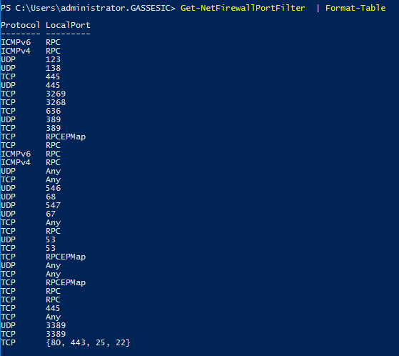

List of All Rules configured

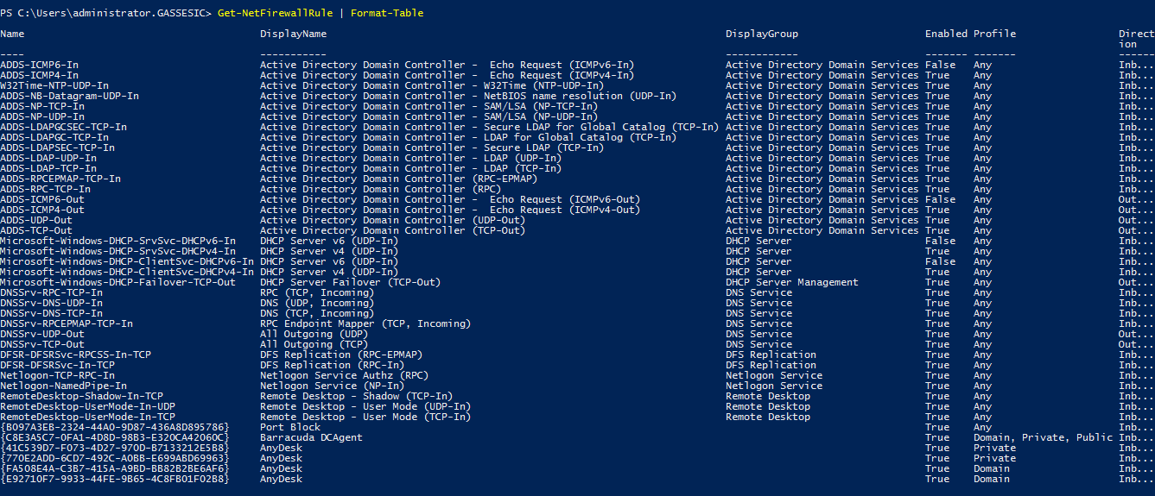

The Port Query Result
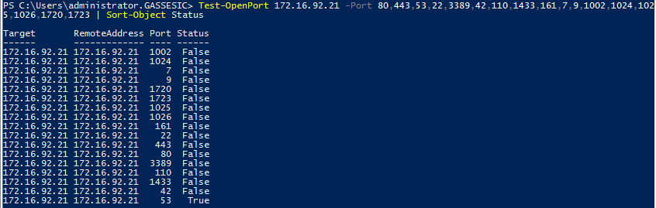

Account Policies Hardening Check List for GIC.
Below is the General Account Policies Hardening guideline for Domain Control Server in GIC Environment.

Password Policy:
Topic | Description | Policy | Yes/NO
Enforce password history | Describes the best practices, location, values, policy management, and security considerations for the Enforce password history security policy setting. | 24 | Yes
Maximum password age | Describes the best practices, location, values, policy management, and security considerations for the Maximum password age security policy setting. | 60 Days | Yes
Minimum password age | Describes the best practices, location, values, policy management, and security considerations for the Minimum password age security policy setting. | 10 Days | Yes
Minimum password length | Describes the best practices, location, values, policy management, and security considerations for the Minimum password length security policy setting. | 8 Character | Yes
Password must meet complexity requirements | Describes the best practices, location, values, and security considerations for the Password must meet complexity requirements security policy setting. | Alpha Numeric, Uppercase, Lowercase, Numeric and symbols. | Yes
Store passwords using reversible encryption | Describes the best practices, location, values, and security considerations for the Store passwords using reversible encryption security policy setting. | Enabled | Yes

Account Lockout Policy for GIC.
Topic | Description | Policy | Yes/No
Account lockout duration | Describes the best practices, location, values, and security considerations for the Account lockout duration security policy setting. | 15 mins | Yes
Account lockout threshold | Describes the best practices, location, values, and security considerations for the Account lockout threshold security policy setting. | 5 Attempts | Yes
Reset account lockout counter after | Describes the best practices, location, values, and security considerations for the Reset account lockout counter after security policy setting. | 15 mins | Yes

Local Group Policy for Audit.
Audit Policy Objects. | Applicable. | Yes/No
Audit account logon events | Success, Failure | Yes
Audit directory service access | Success, Failure | Yes
Audit object access | Success, Failure | Yes
Audit privilege use | Success, Failure | Yes
Audit system events | Success, Failure | Yes
Audit account management | Success, Failure | Yes
Audit logon events | Success, Failure | Yes
Audit policy change | Success, Failure | Yes
Audit process tracking | Success, Failure | Yes

Group Policy for Audit of Domain Server Sub Systems.
Events | Recommendations | Yes/No
Account Logon: Audit Credential Validation | Success and Failure | Yes
Account Logon: Audit Kerberos Authentication Service | Success and Failure | Yes
Account Logon: Audit Kerberos Service Ticket Operations | Success and Failure | Yes
Account Logon: Audit Other Account Logon Events | Success and Failure | Yes
Account Management: Audit Application Group Management | No Auditing | Yes
Account Management: Audit Computer Account Management | Success and Failure | Yes
Account Management: Audit Distribution Group Management | No Auditing | Yes
Account Management: Audit Other Account Management Events | Success and Failure | Yes
Account Management: Audit Security Group Management | Success and Failure | Yes
Account Management: Audit User Account Management | Success and Failure | Yes
Detailed Tracking: Audit DPAPI Activity | Success and Failure | Yes
Detailed Tracking: Audit Process Creation | Success | Yes
Detailed Tracking: Audit PNP Activity | Success | Yes
Detailed Tracking: Audit RPC Events | No Auditing | Yes
DS Access: Audit Detailed Directory Service Replication | Success and Failure | Yes
DS Access: Audit Directory Service Access | Success and Failure | Yes
DS Access: Audit Directory Service Changes | Success and Failure | Yes
DS Access: Audit Directory Service Replication | Success | Yes
Logon/Logoff: Audit Account Lockout | Success and Failure | Yes
Logon/Logoff: Audit User/Device Claims | No Auditing | Yes
Logon/Logoff: Audit Logoff | Success | Yes
Logon/Logoff: Audit Other Logon/Logoff Events | Success and Failure | Yes
Logon/Logoff: Audit Special Logon | Success | Yes
Object Access: Audit Application Generated | A | Yes
Object Access: Audit Removal Storage | Success and Failure | Yes
Policy Change: Audit Policy Change | Success and Failure | Yes
Policy Change: Authentication Policy Change | Success | Yes
Policy Change: Authorization Policy Change | Success | Yes
Privilege Use: Audit Sensitive Privilege Use | Success and Failure | Yes
System: Audit IPSec Driver | Success and Failure | Yes
System: Other System Events | Success and Failure | Yes
System: Security State Change | Success | Yes
System: Security System Extension | Success and Failure | Yes
System: System Integrity | Success and Failure | Yes

AppLocker Hardening Check List for GIC.
Below is the AppLocker Hardening guideline for all Domain Control Server in GIC Environment.
Topic | Description | Policy | Yes/NO
AppLocker\Executable Rules | FilePublisherRule | Deny | Everyone | Block Google Chrome | Deny | Yes
AppLocker\Executable Rules | FilePublisherRule | Deny | Everyone | Block Mozilla Firefox | Deny | Yes
AppLocker\Executable Rules | MICROSOFT® WINDOWS® OPERATING SYSTEM | 10 Days | Yes
AppLocker\Executable Rules | SYMANTEC CORE TECHNOLOGY | 10 Character | Yes
AppLocker\Script | All Script located in the Program Files folder | Allow | Yes
AppLocker\Executable Rules | MICROSOFT SQL SERVER 2016 T-SQL SCRIPTDOM | Allow | Yes
AppLocker\Windows Installer File | All Windows Installer files in %systemdrive%\Windows\Installer | Allow
AppLocker\Windows Installer File | All scripts located in the Windows folder | Allow
AppLocker\Windows Installer File | All digitally signed Windows Installer files | Allow

Server Performance Optimization
Following will be configured on Active Directory Server to optimize the performance of the domain controllers and also to monitor the related performance counters of each sub system with alerting and notification, we recommend to use the server monitoring tool.
- Virtual Memory

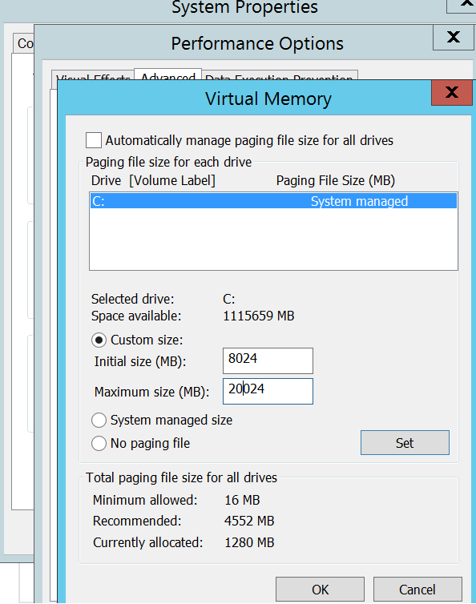
- Performance Optimization
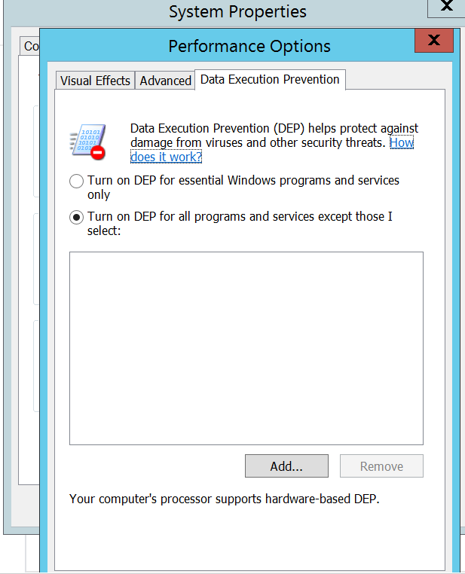

- Data Execution Prevention



- Device Installation Optimization
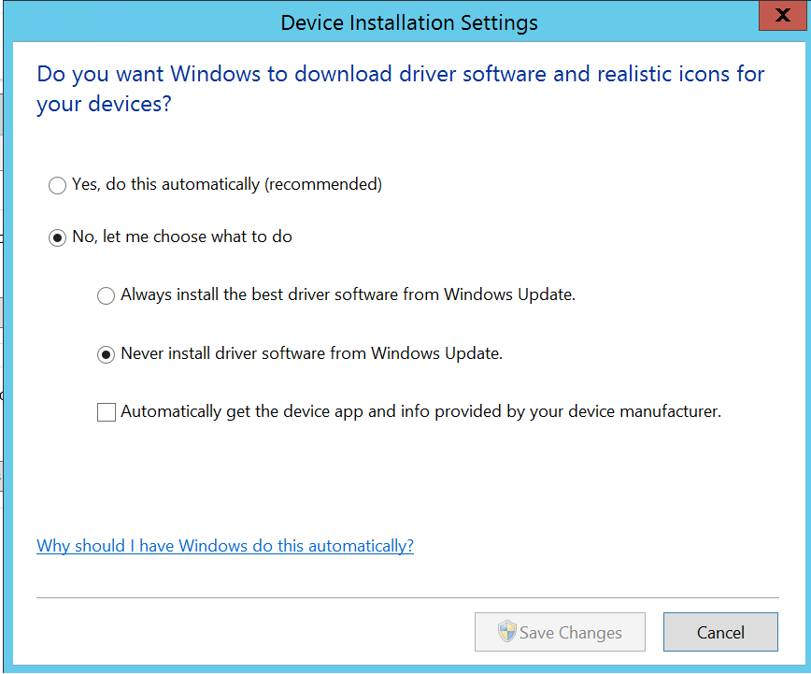
- Startup and Recovery
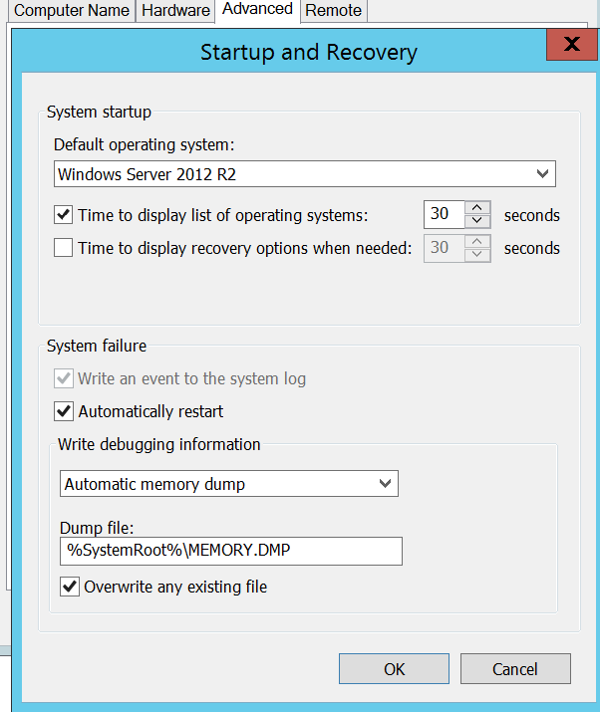

- Disk Defragmentation
Completed

Windows Patch Update
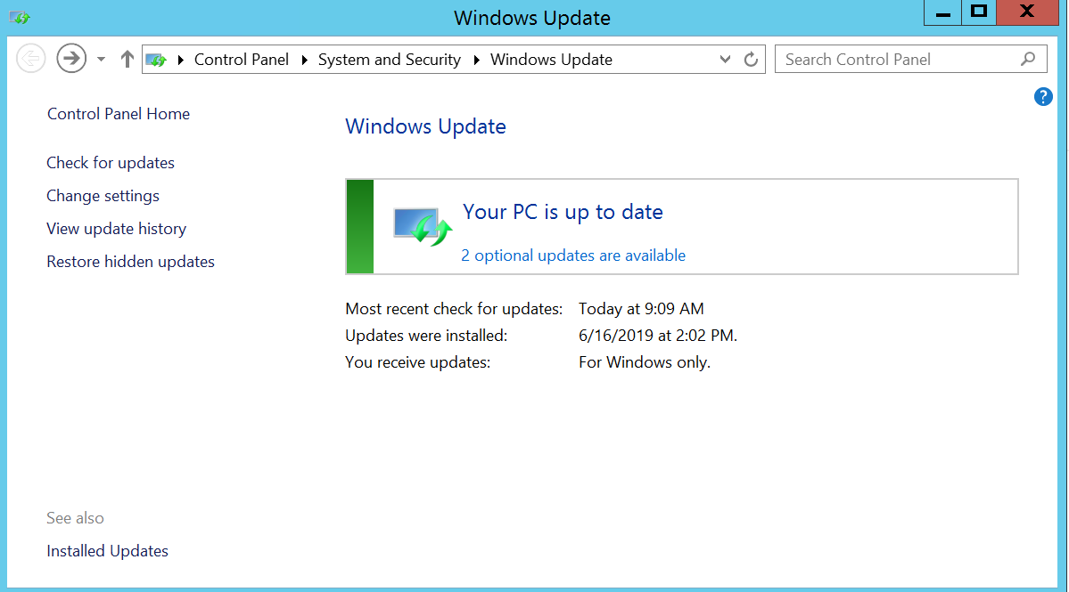

Antivirus Setting

Policy name | Default policy | Description
Antivirus and Antispyware | Yes | Defines the antivirus and antispyware threat scan settings, including how detected processes are handled.
Firewall | Yes | Contains defined the rules and notifications, intrusion protection and active response settings, smart traffic filtering, and traffic and stealth settings.
Intrusion Prevention | Yes | Defines the exceptions to the intrusion detection policy and applies it to groups.
Host Integrity | Yes | Helps define, restore, and enforce the security of clients to keep enterprise networks and data secure.
Application and Device Control | No | USB Block
LiveUpdate | Yes | Specifies the computers that clients must contact to check for updates along with the schedule which defines how often clients must check for updates.
Centralized Exceptions | No | Specifies the exceptions to particular policy features you want to apply.

